Logistic Regression Classification Report

Model Objective
The goal of the logistic regression model was to predict whether a start-up will be successful (status = 1) based on funding history, milestones, industry category, and location indicators.

Model Performance
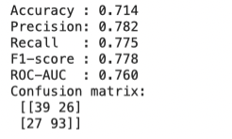

Accuracy: percentage of correct predictions
- About 71.4% of start-ups are classified correctly as success or failure
Precision: when model predicts success, how often is it correct (true positives/predicted positives)
- If the model says a start-up will succeed, it is correct about 77% of the time.
Recall: how many real success did model catch (true positives/actual positives)
- If the model says a startup will succeed, it is correct about 77% of the time.
F1-score: balance of precision and recall
ROC-AUC: measure ranking quality
- Range:
- 0.50 → guessing
- 0.70–0.80 → model has useful signal (0.76 is in this range)
- 0.80+ → strong model

Confusion Matrix:
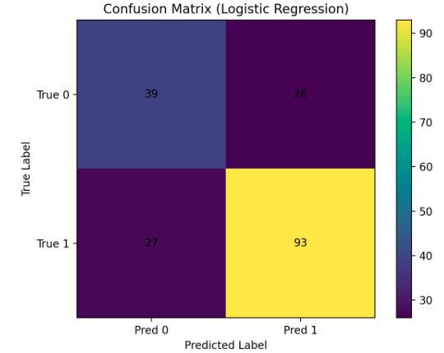
- It correctly identifies many successes (93 true positives).
- It sometimes mistakenly labels failed start-ups as successful (26 false positives).
- It sometimes misses real successful start-ups (27 false negatives).

Cross Validation

Here I ran 5-fold Stratified Cross Validation:
- The training data is split into 5 parts.
- For each fold:
  - The model trains on 4 parts.
  - It predicts on the remaining 1 part (unseen).
- This rotates so every start-up is predicted exactly once without being trained on itself.

Below is the Mean +/- Variabillity of each metric:

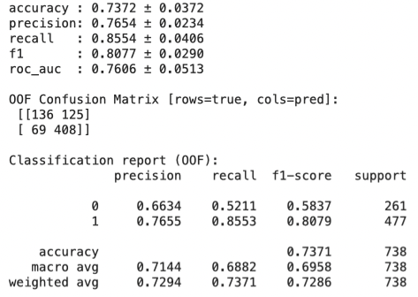
For 00F Confusion Matrix:
- 408 successful startups were correctly predicted
- 69 successful ones were missed (False Negatives)
- 136 failed startups were correctly predicted
- 125 were incorrectly told they would succeed (False Positives)

For Classification report:
- Class 0 (Fail):
precision = 0.66 (only 66% of predicted failures were actually failures)
recall = 0.52 (model misses about half of the real failures)

- Class 1 (Success):
precision = 0.77 (when model predicts success, it's right 77% of the time)
recall = 0.86 (model successfully catches most real successes)
Conclusion: The model is stronger at predicting success than failure

Improvement

If the business cares more about ‘not missing winner (high recall)’, then:
- Lower the threshold from 0.5 to 0.45
If the business cares more about ‘avoiding investing in failure (reduce false positives)’
- Increase threshold to 0.55-0.60

Result Interpretation
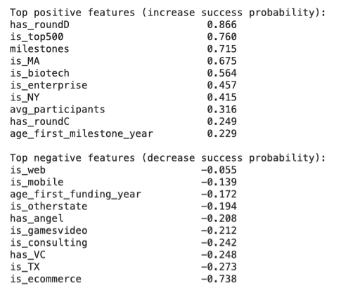

The positive coefficients indicate features that are strongly associated with higher start-up success probability. Start-ups that have progressed to later funding stages such as Round C or Round D show much higher likelihood of success, suggesting that sustained investor backing and growth validation play a critical role. Participation in top-ranked start-up lists (is_top500) and the presence of more milestones also contribute positively, implying that visibility, recognition, and demonstrable progress are key signals of momentum. Sector indicators such as biotech, enterprise, and MA (possibly mergers/acquisitions related sectors) are positively weighted, suggesting that these industries benefit from more supportive funding ecosystems, clearer commercialization pathways, or stronger market demand. Location also matters: being based in New York has a positive coefficient, which likely reflects access to investors, talent, and strategic corporate networks.
The negative coefficients highlight features that are associated with lower chances of success. Startups in ecommerce, consulting, mobile apps, and gaming/video show reduced success probability, which aligns with these sectors often being highly competitive, low-margin, or difficult to scale. The variable has_angel and has_VC appear with negative signs, which suggests that simply having early funding is not enough; success depends more on the stage and traction of funding, not just the presence of investors. Some regional indicators, such as is_TX or is_otherstate, are associated with lower success rates, suggesting that ecosystems outside major startup hubs may lack access to follow-on funding or specialized support networks. Additionally, earlier milestone age variables have negative influence, meaning that longer time to reach early progress signals may reflect slower execution or weaker product-market fit.

